23.57: a) (i) 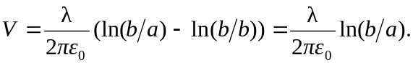
(ii) 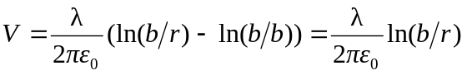.
(iii) 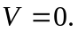
b) 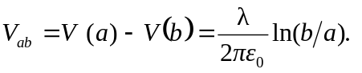
c) Between the cylinders:
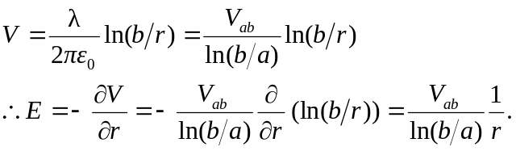

d) The potential difference between the two cylinders is identical to that in part (b) even if the outer cylinder has no charge.

